

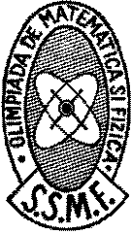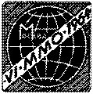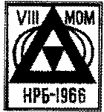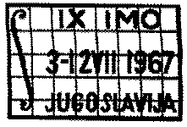

IMO 1959 – 1968

Questions and Solutions

N. Russell S.

**IMO 1959**

**Day 1**

1. Prove that the fraction 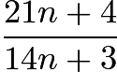 is irreducible for every natural number $ n$.
2. For what real values of $x$ is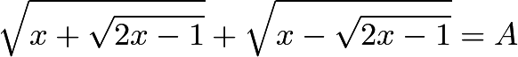given  
     
   a) $A=\sqrt{2}$;  
     
   b) $A=1$;  
     
   c) $A=2$,  
     
   where only non-negative real numbers are admitted for square roots?
3. Let $a,b,c$ be real numbers. Consider the quadratic equation in $\cos{x}$\[ a \cos{x}^2+b \cos{x}+c=0.  \]Using the numbers $a,b,c$ form a quadratic equation in $\cos{2x}$ whose roots are the same as those of the original equation. Compare the equation in $\cos{x}$ and $\cos{2x}$ for $a=4$, $b=2$, $c=-1$.

**Day 2**

1. Construct a right triangle with given hypotenuse $c$ such that the median drawn to the hypotenuse is the geometric mean of the two legs of the triangle.
2. An arbitrary point $M$ is selected in the interior of the segment $AB$. The square $AMCD$ and $MBEF$ are constructed on the same side of $AB$, with segments $AM$ and $MB$ as their respective bases. The circles circumscribed about these squares, with centers $P$ and $Q$, intersect at $M$ and also at another point $N$. Let $N'$ denote the point of intersection of the straight lines $AF$ and $BC$.  
     
   a) Prove that $N$ and $N'$ coincide;  
     
   b) Prove that the straight lines $MN$ pass through a fixed point $S$ independent of the choice of $M$;  
     
   c) Find the locus of the midpoints of the segments $PQ$ as $M$ varies between $A$ and $B$.
3. Two planes, $P$ and $Q$, intersect along the line $p$. The point $A$ is given in the plane $P$, and the point $C$ in the plane $Q$; neither of these points lies on the straight line $p$. Construct an isosceles trapezoid $ABCD$ (with $AB \parallel CD$) in which a circle can be inscribed, and with vertices $B$ and $D$ lying in planes $P$ and $Q$respectively.



The 1st [IMO](https://www.artofproblemsolving.com/wiki/index.php?title=IMO) occurred in 1959 in Bucharest, Romania. Seven countries participated. Teams were of eight students. Unofficially, Romania finished first, with 249 of 336 possible points.

IMO 1959 Solutions

1. **First Solution**

We observe that

$3(14n+3) = 2(21n+4) + 1.$

Since a multiple of $14n+3$ differs from a multiple of $21n+4$ by 1, we cannot have any postive integer greater than 1 simultaneously divide $14n+3$and $21n+4$. Hence the [greatest common divisor](https://www.artofproblemsolving.com/wiki/index.php?title=Greatest_common_divisor) of the fraction's numerator and denominator is 1, so the fraction is irreducible. Q.E.D.

**Second Solution**

Denoting the greatest common divisor of $a, b$ as $(a,b)$, we use the [Euclidean algorithm](https://www.artofproblemsolving.com/wiki/index.php?title=Euclidean_algorithm) as follows:

$( 21n+4, 14n+3 ) = ( 7n+1, 14n+3 ) = ( 7n+1, 1 ) = 1$

As in the first solution, it follows that  is irreducible. Q.E.D.

**Third Solution**

[Proof by contradiction](https://www.artofproblemsolving.com/wiki/index.php?title=Proof_by_contradiction):

Assume that 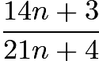 is a [reducible fraction](https://www.artofproblemsolving.com/wiki/index.php?title=Reducible_fraction) where $p$ is a [divisor](https://www.artofproblemsolving.com/wiki/index.php?title=Divisor) of both the [numerator](https://www.artofproblemsolving.com/wiki/index.php?title=Numerator) and the [denominator](https://www.artofproblemsolving.com/wiki/index.php?title=Denominator):

$14n+3\equiv 0\pmod{p} \implies 42n+9\equiv 0\pmod{p}$

$21n+4\equiv 0\pmod{p} \implies 42n+8\equiv 0\pmod{p}$

Subtracting the second [equation](https://www.artofproblemsolving.com/wiki/index.php?title=Equation) from the first [equation](https://www.artofproblemsolving.com/wiki/index.php?title=Equation) we get $1\equiv 0\pmod{p}$ which is clearly absurd.

Hence  is irreducible. Q.E.D.

**Fourth Solution**

Let $g = {\rm gcd}(21n + 4, 14n + 3)$. Then $g|h$ where $h = {\rm gcd}(42n + 8, 14n + 3) = {\rm gcd}(1, 14n + 3) = 1$. Thus, $g = h = 1$. *Note: This solution, in hindsight, is just the first solution above in a slightly different notation.*

**Fifth Solution**

We notice that:

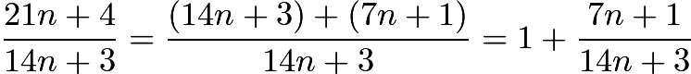

So it follows that $7n+1$ and $14n+3$ must be coprime for every natural number $n$ for the fraction to be irreducible. Now the problem simplifies to proving 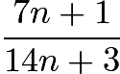 irreducible. We re-write this fraction as:

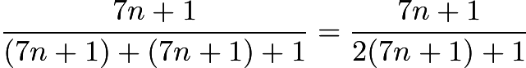

Since the denominator $2(7n+1) + 1$ differs from a multiple of the numerator $7n+1$ by 1, the numerator and the denominator must be relatively prime natural numbers. Hence it follows that  is irreducible.

Q.E.D

1. We note that the square roots imply that 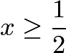. We now square both sides and simplify to obtain

$A^2 = 2(x+|x-1|)$

If $x \le 1$, then we must clearly have $A^2 =2$. Otherwise, we have

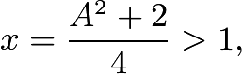

$A^2 > 2$

Hence for (a) the solution is 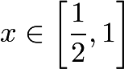, for (b) there is no solution, since we must have $A^2 \ge 2$, and for (c), the only solution is 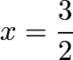. Q.E.D.

1. Let the original equation be satisfied only for $\cos{x}=m, \cos{x}=n$. Then we wish to construct a quadratic with roots $2m^2 -1, 2n^2 -1$.

Clearly, the sum of the roots of this quadratic must be

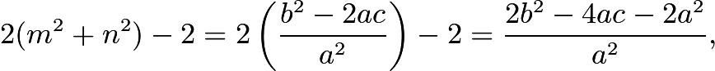

and the product of its roots must be



Thus the following quadratic fulfils the conditions:

$a^2 \cos ^2 {2x} + (2a^2 + 4ac - 2b^2)\cos{2x} + (a+2c)^2 - 2b^2 = 0$

Now, when we let $a=4, b=2, c= -1$, our equations are

$4 \cos^2 {x} + 2 \cos {x} - 1 = 0$

and

$16 \cos^2 {2x} - 8 \cos {2x} - 4 = 0,$

The roots of the first equation are 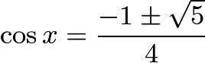, which implies that $x$ is one of two certain multiples of $\frac{\pi}{5}$. The roots of the second equation are 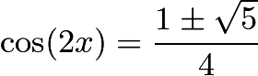. It is straightforward to verify that they result in the same values of $x$.

1. We denote the [catheti](https://www.artofproblemsolving.com/wiki/index.php?title=Cathetus" \o "Cathetus) of the triangle as $a$ and $b$. We also observe the well-known fact that in a right triangle, the median to the hypotenuse is of half the length of the hypotenuse. (This is true because if we inscribe the triangle in a circle, the hypotenuse is the diameter, so a segment from any point on the circle to the midpoint of the hypotenuse is a radius.)

### Solution 1

The conditions of the problem require that

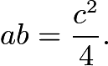

However, we notice that twice the area of the triangle $abc$ is $ab$, since $a$ and $b$ form a right angle. However, twice the area of the triangle is also the product of $c$ and the altitude to $c$. Hence the altitude to $c$ must have length $\frac{c}{4}$. Therefore if we construct a circle with diameter $c$ and a line parallel to $c$and of distance $\frac{c}{4}$ from $c$, either point of intersection between the line and the circle will provide a suitable third vertex for the triangle. Q.E.D.

### Solution 2

We denote the angle between $b$ and $c$ as $\alpha$. The problem requires that

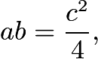

or, equivalently, that

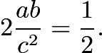

However, since 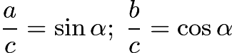, we can rewrite the condition as

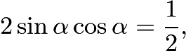

or, equivalently, as

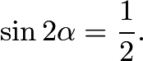

From this it becomes apparent that 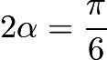 or $\frac{5\pi}{6}$; hence the other two angles in the triangle must be $\frac{ \pi }{12}$ and $\frac{ 5 \pi }{12}$, which are not difficult to construct. Q.E.D.

*Note*. It is not difficult to reconcile these two constructions. Indeed, we notice that the altitude of the triangle is of length $c \sin{\alpha}\cos{\alpha}$, which both of the solutions set equal to $\frac{c}{4}$ .

## **Solution 3**

If we let the legs be $a$ and $b$ with $a < b$, then $c^2 = a^2 + b^2$. Because $4c^2 = a^2 b^2$ as well, we immediately deduce via some short computations that $a = (2 - \sqrt{3})b$. Thus, 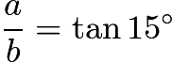, and so one of the angles of the triangle must be $15^\circ$. But a $15^\circ$ angle is easily constructed by bisecting a $30^\circ$angle (which is formed by constructing the altitude of an equilateral triangle), and from there it is not difficult to construct the desired right triangle.

### Part A

Since the triangles $AFM, CBM$ are congruent, the angles $AFM, CBM$ are congruent; hence $AN'B$ is a right angle. Therefore $N'$ must lie on the circumcircles of both quadrilaterals; hence it is the same point as $N$.

[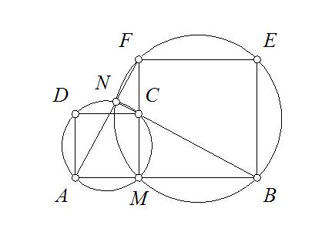](https://www.artofproblemsolving.com/wiki/index.php?title=File:1IMO5A.JPG)

### Part B

We observe that 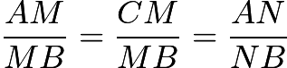 since the triangles $ABN, BCN$ are similar. Then $NM$ bisects $ANB$.

We now consider the circle with diameter $AB$. Since $ANB$ is a right angle, $N$ lies on the circle, and since $MN$ bisects $ANB$, the arcs it intercepts are congruent, i.e., it passes through the bisector of arc $AB$ (going counterclockwise), which is a constant point.

### Part C

Denote the midpoint of $PQ$ as $R$. It is clear that $R$'s distance from $AB$ is the average of the distances of $P$ and $Q$ from $AB$, i.e., half the length of $AB$, which is a constant. Therefore the locus in question is a line segment.

1. We first observe that we must have both lines $AB$ (which we shall denote $a$) and $DC$ (which we shall denote $c$) parallel to $p$, since if one of them is not, then neither can be and they must both intersect $p$ (since they are both coplanar with $p$), making them [skew](https://www.artofproblemsolving.com/wiki/index.php?title=Skew_lines).

Now we note since a circle can be inscribed in the trapezoid, we must have $AB + DC = AD + BC$, and since the trapezoid is isosceles, this implies that each of the trapezoid's legs has length equal to the [average](https://www.artofproblemsolving.com/wiki/index.php?title=Arithmetic_mean) of the lengths of the bases.

We can find this average by dropping [perpendicular](https://www.artofproblemsolving.com/wiki/index.php?title=Perpendicular) $AA'$ to $c$ such that $A'$ is on $c$. The average will be $A'C$, which is one of the sides of the [rectangle](https://www.artofproblemsolving.com/wiki/index.php?title=Rectangle" \o "Rectangle)with sides on $a$ and $c$ with vertices at $A$ and ${C}$.

We now draw a circle with center ${C}$ that contains $A'$. The intersections of this circle with $a$ are the two possible values of $B$, from either of which it is trivial to determine the corresponding location for $D$. It is worth noting that the intersection points may concur (in which case there is only one distinct possibility (a square)), or they may not occur at all. Q.E.D.

**IMO 1960**

**Day 1**

1. Determine all three-digit numbers $N$ having the property that $N$ is divisible by 11, and $\dfrac{N}{11}$ is equal to the sum of the squares of the digits of $N$.
2. For what values of the variable $x$ does the following inequality hold:

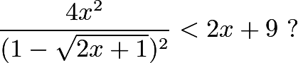

1. In a given right triangle $ABC$, the hypotenuse $BC$, of length $a$, is divided into $n$ equal parts ($n$ and odd integer). Let $\alpha$ be the acute angel subtending, from $A$, that segment which contains the mdipoint of the hypotenuse. Let $h$ be the length of the altitude to the hypotenuse fo the triangle. Prove that: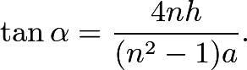

**Day 2**

1. Construct triangle $ABC$, given $h_a$, $h_b$ (the altitudes from $A$ and $B$), and $m_a$, the median from vertex $A$.
2. Consider the cube $ABCDA'B'C'D'$ (with face $ABCD$ directly above face $A'B'C'D'$).  
     
   a) Find the locus of the midpoints of the segments $XY$, where $X$ is any point of $AC$ and $Y$ is any piont of $B'D'$;  
     
   b) Find the locus of points $Z$ which lie on the segment $XY$ of part a) with $ZY=2XZ$.
3. Consider a cone of revolution with an inscribed sphere tangent to the base of the cone. A cylinder is circumscribed about this sphere so that one of its bases lies in the base of the cone. let $V_1$ be the volume of the cone and $V_2$ be the volume of the cylinder.  
     
   a) Prove that $V_1 \neq V_2$;  
     
   b) Find the smallest number $k$ for which $V_1=kV_2$; for this case, construct the angle subtended by a diamter of the base of the cone at the vertex of the cone.
4. An isosceles trapezoid with bases $a$ and $c$ and altitude $h$ is given.  
     
   a) On the axis of symmetry of this trapezoid, find all points $P$ such that both legs of the trapezoid subtend right angles at $P$;  
     
   b) Calculate the distance of $p$ from either base;  
     
   c) Determine under what conditions such points $P$ actually exist. Discuss various cases that might arise.

The 2nd [IMO](https://www.artofproblemsolving.com/wiki/index.php?title=IMO) occurred in 1960 in Sinaia, Romania. Five countries participated. Teams were of eight students.

IMO 1960 Solutions

### Solution 1

Let $N = 100a + 10b+c$ for some digits $a,b,$ and $c$. Then\[100a + 10b+c = 11m\]for some $m$. We also have $m=a^2+b^2+c^2$. Substituting this into the first equation and simplification, we get\[100a+10b+c = 11a^2 +11b^2 +11c^2\]For an integer divisible by $11$, the the sum of digits in the odd positions minus the sum of digits in the even positions is divisible by $11$. Thus we get: $b = a + c$ or $b = a + c - 11$.

Case $1$: Let $b=a+c$. We get\[100a+c+10a+10c = 11a^2 +11c^2+11(a+c)^2\]\[10a+c = 2a^2+2ac+2c^2\]Since the right side is even, the left side must also be even. Let $c=2q$ for some $q = 0,1,2,3,4$. Then\[10a+2q=2a^2+4aq+8q^2\]\[5a+q=a^2+2aq+4q^2\]Substitute $q=0,1,2,3,4$ into the last equation and then solve for $a$.

When $q=0$, we get $a=5$. Thus $c=0$ and $b=5$. We get that $N=550$ which works.

When $q=1$, we get that $a$ is not an integer. There is no $N$ for this case.

When $q=2$, we get that $a$ is not an integer. There is no $N$ for this case.

When $q=3$, we get that $a$ is not an integer. There is no $N$ for this case.

When $q=4$, we get that $a$ is not an integer. There is no $N$ for this case.

Case $2$: Let $b = a + c - 11$. We get\[100a+c+10a+10c -110= 11(a^2+(a+c)^2-22(a+c)+c^2+121)\]\[10a+c=2a^2+2c^2+2ac-22a-22c+131\]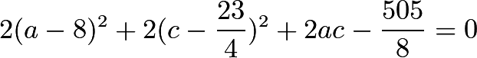Now we test all $c=0\rightarrow10$. When $c=0,1,2,4,5,6,7,8,9$, we get no integer solution to $a$. Thus, for these values of $c$, there is no valid $N$. However, when $c=3$, we get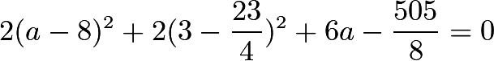\[2(a-8)^2+6a-48 = 0\]We get that $a=8$ is a valid solution. For this case, we get $a=8,b=0,c=3$, so $N=803$, and this is a valid value. Thus, the answers are $\boxed{N=550,803}$.

### Solution 2

Define a **ten** to be all ten positive integers which begin with a fixed tens digit.

We can make a systematic approach to this:

By inspection, $\dfrac{N}{11}$ must be between 10 and 90 inclusive. That gives us 8 tens to check, and 90 as well.

For a given ten, the sum of the squares of the digits of $N$ increases faster than $\dfrac{N}{11}$, so we can have at most one number in every ten that works.

We check the first ten:

$11*11=121$

$1^2+2^2+1^2=4$

$12*11=132$

$1^2+3^2+2^2=14$

11 is too small and 12 is too large, so all numbers below 11 will be too small and all numbers above 12 will be too large, so no numbers in the first ten work.

We try the second ten:

$21*11=231$

$2^2+3^2+1^2=14$

$22*11=242$

$2^2+4^2+2^2=24$

Therefore, no numbers in the second ten work.

We continue, to find out that 50 and 73 are the only ones that works.

$N=50*11=550$, $N=73*11=803$ so there are two $N$ that works.

1. Set 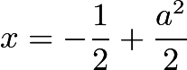, where $a\ge0$. 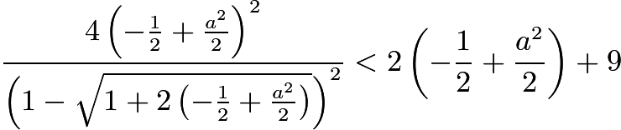

After simplifying, we get $(a+1)^2<a^2+8$

So $a^2+2a+1<a^2+8$

Which gives 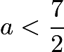 and hence 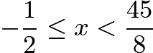.

But $x=0$ makes the RHS indeterminate.

So, answer: , except $x=0$.

## **Solution 1**

## Using coordinates, let $A=(0,0)$, $B=(b,0)$, and $C=(0,c)$. Also, let $PQ$ be the segment that contains the midpoint of the hypotenuse with $P$closer to $B$.

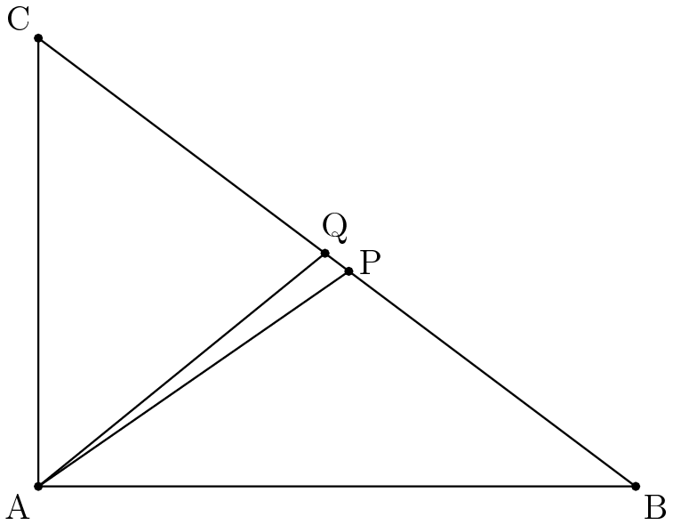

Then, 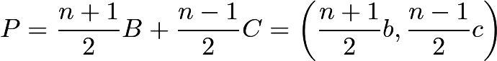, and .

So, $\text{slope}$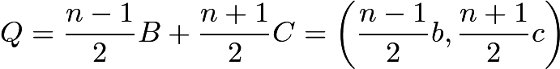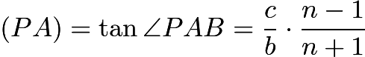, and $\text{slope}$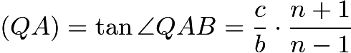.

Thus, 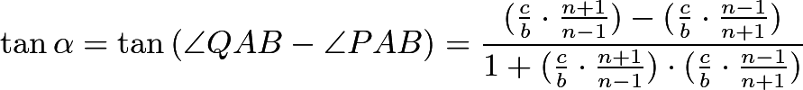 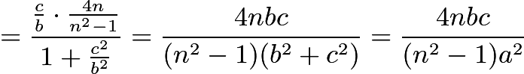.

Since 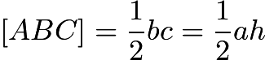, $bc=ah$ and 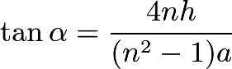 as desired.

## **Solution 2**

Let $P, Q, R$ be points on side $BC$ such that segment $PR$ contains midpoint $Q$, with $P$ closer to $C$ and (without loss of generality) $AC \le AB$. Then if $AD$ is an altitude, then $D$ is between $P$ and $C$. Combined with the obvious fact that $Q$ is the midpoint of $PR$ (for $n$ is odd), we have



1. Let $M_a$, $M_b$, and $M_c$ be the midpoints of sides $\overline{BC}$, $\overline{CA}$, and $\overline{AB}$, respectively. Let $H_a$, $H_b$, and $H_c$ be the feet of the altitudes from $A$, $B$, and $C$ to their opposite sides, respectively. Since $\triangle ABC\sim\triangle M_bM_aC$, with 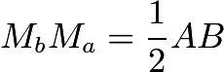, the distance from $M_a$ to side $\overline{AC}$ is $\frac{h_b}{2}$.

Construct $AM_a$ with length $m_a$. Draw a circle centered at $A$ with radius $h_a$. Construct the tangent $l_1$ to this circle through $M_a$. $\overline{BC}$ lies on $l_1$.

Draw a circle centered at $M_a$ with radius $\frac{h_b}{2}$. Construct the tangent $l_2$ to this circle through $A$. $\overline{AC}$ lies on $l_2$. Then $C=l_1\cap l_2$.

Construct the line $l_3$ parallel to $l_2$ so that the distance between $l_2$ and $l_3$ is $h_b$ and $M_a$ lies between these lines. $B$ lies on $l_3$. Then $B=l_1\cap l_3$.

1. Let $A=(0,0,2)$, $B=(2,0,2)$, $C=(2,0,0)$, $D=(0,0,0)$, $A'=(0,2,2)$, $B'=(2,2,2)$, $C'=(2,2,0)$, and $D'=(0,2,0)$. Then there exist real $x$ and $y$ in the closed interval $[0,2]$ such that $X=(x,0,2-x)$ and $Y=(y,2,y)$.

The midpoint of $XY$ has coordinates $((x+y)/2, 1, (2-x+y)/2)$. Let $a$ and $b$ be the $x$- and $z$-coordinates of the midpoint of $XY$, respectively. We then have that $a+b=y+1$ and $a-b=x-1$, so $a+b\in [1,3]$ and $a-b\in [-1,1]$. The region of points that satisfy these inequalities is the closed square with vertices at $(1,1,2)$, $(2,1,1)$, $(1,1,0)$, and $(0,1,1)$. For every point $P$ in this region, there exist unique points $X$ and $Y$ such that $P$ is the midpoint of $XY$.

If $Z\in XY$ and $ZY=2XZ$, then $Z$ has coordinates $((2x+y)/3, 2/3, (4-2x+y)/3)$. Let $a$ and $b$ be the $x$- and $z$- coordinates of $Z$. We then have that $a+b=(4/3)+(2/3)y$ and $a-b=(4x-4)/3$, and $a\in (4/3,8/3)$ and $b\in (-4/3,4/3)$. The region of points that satisfy these inequalities is the closed rectangle with vertices at $(0,2/3,4/3)$, $(2/3,2/3,1)$, $(1,2/3,2/3)$, and $(4/3,2/3,0)$. For every point $Z$ in this region, there exist unique points $X$ and $Y$ such that $Z\in XY$ and $ZY=2XZ$.

1. **Part (a):**

Let $R$ denote the radius of the cone, and let $r$ denote the radius of the cylinder and sphere. Let $l$ denote the slant height of the cone, and let $h$ denote the height of the cone.

Consider a plane that contains the axis of the cone. This plane will slice the cone and sphere into a circle $\omega$ inscribed in an isosceles triangle $T$.

The area of $T$ may be computed in two different ways: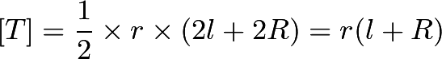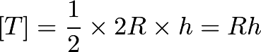From this, we deduce that 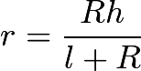.

Now, we calculate our volumes: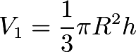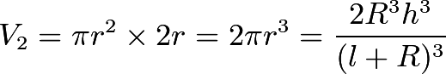Now, we will compute the quantity 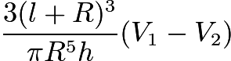 and prove that it is always greater than $0$. Let 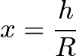. Clearly, $x$ can be any positive real number. Define 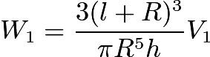 and 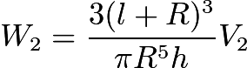. We will calculate $W_1$ and $W_2$ in terms of $x$ and then compute the desired quantity $W_1 - W_2$.

It is easy to see that:\[W_1 = (\sqrt{x^2+1} + 1)^3\]\[W_2 = 6x^2\]

Now, let $u = \sqrt{x^2+1}$. Since $x > 0$, it follows that $u > 1$. We now have:\[W_1 = (u + 1)^3\]\[W_2 = 6(u^2 - 1)\]

Define $f(u) = W_1 - W_2$. It follows that:\[f(u) = (u+1)^3 - 6(u^2 - 1)\]\[f(u) = u^3 - 3u^2 + 3u + 7\]\[f(u) = (u-1)^3 + 8 > 8 > 0\]

We see that $f(u) > 8$ for all allowed values of $u$. Thus, 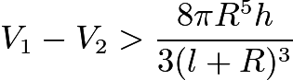, meaning that $V_1 > V_2$. We have thus proved that $V_1 \ne V_2$, as desired.

**Part (b):**

From our earlier work in calculating the volumes $V_1$ and $V_2$, we easily see that: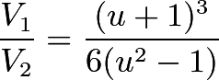Re-expressing and simplifying, we have: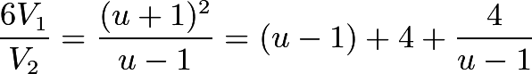. By the AM-GM Inequality, 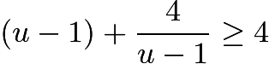, meaning that 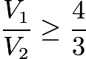. Equality holds if and only if 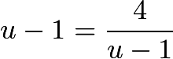, meaning that $u=3$ and $x = 2\sqrt{2}$.

If we check the case 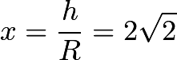, we may calculate $V_1$ and $V_2$: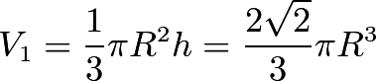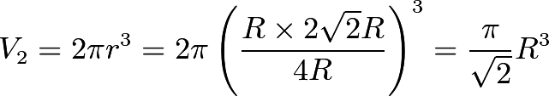Indeed, we have 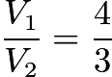, meaning that our minimum of 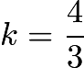 can be achieved.

Thus, we have proved that the minimum value of $k$ such that $V_1 = kV_2$ is $\frac{4}{3}$.

Now, let $\theta$ be the angle subtended by a diameter of the base of the cone at the vertex of the cone. We have the following: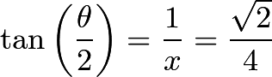From the double-angle formula for tangent,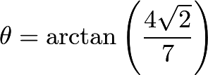This angle is easy to construct. Simply take any segment and treat it as a unit segment. Create a right triangle with legs of lengths $4\sqrt{2}$ and $7$. This is straightforward, and the angle opposite the leg of length $4\sqrt{2}$ will be the desired angle $\theta$.

It follows that we have successfully constructed the desired angle $\theta$.

1. (a) The intersection of the circle with diameter one of the legs with the axis of symmetry.

(b) Let $x$ be the distance from $P$ to one of the bases; then $h - x$ must be the distance from $P$ to the other base. Similar triangles give 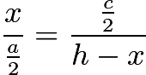, so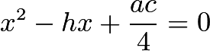 and so 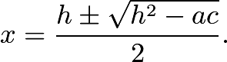

(c) When $h^2 \ge ac$.

ABCD is our trapezoid with AB=a and CD=c and its height is 'h'. AF and BE are perpendicular to CD such that AF= BE= h. XY is our axis of symmetry and it intersects with CD at a point O. Point O is our origin of reference whose coordinates are (0,0).

Let our point P be on the axis of symmetry at z distance from the origin O.

The coordinates of the points A,B,C,D,E,F and P are given in the figure.

Now,

Slope of the line PC= (z-0)/(0-c/2) = -2z/c Slope of the line PB= (z-h)/(0-a/2) = -2(z-h)/a

Since the leg BC subtends a right angle at P, the angle BPC should be a right angle. This means that the product of the slope of PC and PB is -1.

i.e

4z(z-h)=-ac

or z^2 - zh + ac/4= O

Now, solving for z, we get, z= [(h + ( h^2 - ac ) ^1/2 ]/2 and [(h - ( h^2 - ac ) ^1/2 ]/2

So, z is the distance of the points from the base CD..

Also the points are possible only when , h^2 - ac >= 0.. and doesn't exist for h^2 -ac <0

**IMO 1961**

**Day 1**

1. Solve the system of equations:

\[ x+y+z=a  \]

\[ x^2+y^2+z^2=b^2  \]

\[ xy=z^2  \]

where $a$ and $b$ are constants. Give the conditions that $a$ and $b$ must satisfy so that $x,y,z$ are distinct positive numbers.

1. Let $ a$, $ b$, $ c$ be the sides of a triangle, and $ S$ its area. Prove:  
   \[ a^{2} + b^{2} + c^{2}\geq 4S \sqrt {3}
   \]  
   In what case does equality hold?
2. Solve the equation $\cos^n{x}-\sin^n{x}=1$ where $n$ is a natural number.

**Day 2**

1. Consider triangle $P_1P_2P_3$ and a point $p$ within the triangle. Lines $P_1P, P_2P, P_3P$ intersect the opposite sides in points $Q_1, Q_2, Q_3$ respectively. Prove that, of the numbers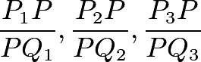  
   at least one is $\leq 2$ and at least one is $\geq 2$
2. Construct a triangle $ABC$ if $AC=b$, $AB=c$ and $\angle AMB=w$, where $M$ is the midpoint of the segment $BC$ and $w<90$. Prove that a solution exists if and only if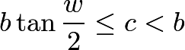In what case does the equality hold?
3. Consider a plane $\epsilon$ and three non-collinear points $A,B,C$ on the same side of $\epsilon$; suppose the plane determined by these three points is not parallel to $\epsilon$. In plane $\epsilon$take three arbitrary points $A',B',C'$. Let $L,M,N$ be the midpoints of segments $AA', BB', CC'$; Let $G$ be the centroid of the triangle $LMN$. (We will not consider positions of the points $A', B', C'$ such that the points $L,M,N$ do not form a triangle.) What is the locus of point $G$ as $A', B', C'$ range independently over the plane $\epsilon$?

The 3rd [IMO](https://www.artofproblemsolving.com/wiki/index.php?title=IMO) occurred in 1961 in Budapest, Hungary.

IMO 1961 Solutions

1. Note that $x^2 + y^2 = (x+y)^2 - 2xy = (x+y)^2 - 2z^2$, so the first two equations become

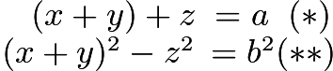.

We note that , so if $a$ equals 0, then $b$ must also equal 0. We then have $x+y = -z$; $xy = (x+y)^2$. This gives us $x^2 + xy + y^2 = 0$. Mutiplying both sides by $(x-y)$, we have $x^3 - y^3 = 0$. Since we want $x,y$ to be real, this implies $x = y$. But $x^2 + x^2 + x^2$ can only equal 0 when $x=0$ (which, in this case, implies $y,z = 0$). Hence there are no positive solutions when $a = 0$.

When $a \neq 0$, we divide $(**)$ by $(*)$ to obtain the system of equations

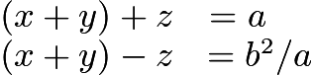,

which clearly has solution 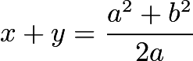, 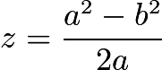. In order for these both to be positive, we must have positive $a$ and $a^2 > b^2$. Now, we have ; 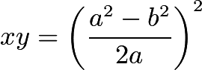, so $x,y$ are the roots of the quadratic 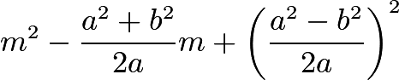. The [discriminant](https://www.artofproblemsolving.com/wiki/index.php?title=Discriminant) for this equation is

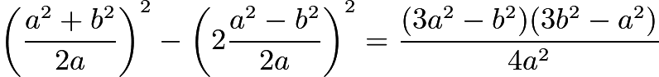.

If the expressions $(3a^2 - b^2), (3b^2 - a^2)$ were simultaneously negative, then their sum, $2(a^2 + b^2)$, would also be negative, which cannot be. Therefore our quadratic's discriminant is positive when $3a^2 > b^2$ and $3b^2 > a^2$. But we have already replaced the first inequality with the sharper bound $a^2 > b^2$. It is clear that both roots of the quadratic must be positive if the discriminant is positive (we can see this either from 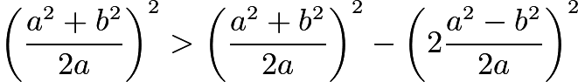 or from [Descartes' Rule of Signs](https://www.artofproblemsolving.com/wiki/index.php?title=Polynomial#Descartes.27_Law_of_Signs)). We have now found the solutions to the system, and determined that it has positive solutions if and only if $a$ is positive and $3b^2 > a^2 > b^2$. Q.E.D.

1. Substitute 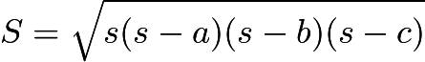, where 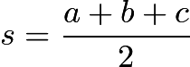

This shows that the inequality is equivalent to $a^2b^2+b^2c^2+c^2a^2\le a^4+b^4+c^4$.

This can be proven because 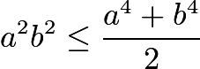. The equality holds when $a=b=c$, or when the triangle is equilateral.

1. Since $cos^2x + sin^2x = 1$, we cannot have solutions with $n\ne2$ and $0<|cos(x)|,|sin(x)|<1$. Nor can we have solutions with $n=2$, because the sign is wrong. So the only solutions have $sin (x) = 0$ or $cos (x) = 0$, and these are: $x =$ multiple of $\pi$, and $n$ even; $x$ even multiple of $\pi$and $n$ odd; $x$ = even multiple of 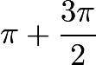 and $n$ odd.
2. Let $[ABC]$ denote the area of triangle $ABC$.

Since triangles $P_1P_2P_3$ and $PP_2P_3$ share the base $P_2P_3$, we have 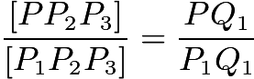.

Similarly, 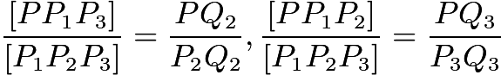.

Adding all of these gives .

We see that we must have at least one of the three fractions not greater than $\frac{1}{3}$, and at least one not less than $\frac{1}{3}$. These correspond to ratios 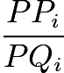being less than or equal to $2$, and greater than or equal to $2$, respectively, so we are done.

1. Prolong BA to a point D such that $BD = 2AB$. Take circle through B and D such that the minor arc BD is equal to $2*\omega$ so that for points P on the major arc BD we have $\angle BPD = \omega$. Draw a circle with center A and radius AC, and the point of intersection of this circle and the major arc BD will be C. In general there are two possibilities for C.

Let X be the intersection of the arc BN and the perpendicular to the segment BN through A. For the construction to be possible we require $AX \geqslant AC > AB$. But 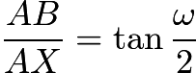, so we get the condition in the question.

1. We will consider the various points in terms of their coordinates in space. We have 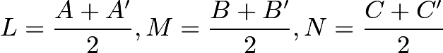. Since the centroid of a triangle is the average of the triangle's vertices, we have . It is clear now that $G$is midpoint of the line segment connecting the centroid of $ABC$ and the centroid of $A^\prime B^\prime C^\prime$. It is obvious that the centroid of $A^\prime B^\prime C^\prime$ can be any point on plane $\epsilon$. Thus, the locus of $G$ is the plane parallel to $\epsilon$ and halfway between the centroid of $ABC$ and $\epsilon$.

**IMO 1962**

The 4th [IMO](https://www.artofproblemsolving.com/wiki/index.php?title=IMO) occurred in 1962 in Czechoslovakia.

## **Day I**

### Problem 1

Find the smallest natural number $n$ which has the following properties:

(a) Its decimal representation has 6 as the last digit.

(b) If the last digit 6 is erased and placed in front of the remaining digits, the resulting number is four times as large as the original number $n$.

### Problem 2

Determine all real numbers $x$ which satisfy the inequality:

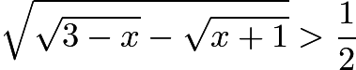

### Problem 3

Consider the cube $ABCDA'B'C'D'$($ABCD$ and $A'B'C'D'$ are the upper and lower bases, respectively, and edges $AA'$, $BB'$, $CC'$, $DD'$ are parallel). The point $X$ moves at constant speed along the perimeter of the square $ABCD$ in the direction $ABCDA$, and the point $Y$ moves at the same rate along the perimeter of the square $B'C'CB$ in the direction $B'C'CBB'$. Points $X$ and $Y$ begin their motion at the same instant from the starting positions $A$ and $B'$, respectively. Determine and draw the locus of the midpoints of the segments $XY$.

## **Day II**

### Problem 4

Solve the equation $cos^2{x}+cos^2{2x}+cos^2{3x}=1$.

### Problem 5

On the circle $K$ there are given three distinct points $A,B,C$. Construct (using only straightedge and compass) a fourth point $D$ on $K$ such that a circle can be inscribed in the quadrilateral thus obtained.

### Problem 6

Consider an isosceles triangle. Let $r$ be the radius of its circumscribed circle and $\rho$ the radius of its inscribed circle. Prove that the distance $d$ between the centers of these two circles is

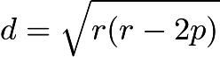.

### Problem 7

The tetrahedron $SABC$ has the following property: there exist five spheres, each tangent to the edges $SA, SB, SC, BC, CA, AB$, or to their extensions.

(a) Prove that the tetrahedron $SABC$ is regular.

(b) Prove conversely that for every regular tetrahedron five such spheres exist.



IMO 1962 Solutions

1. As the new number starts with a $6$ and the old number is $1/4$ of the new number, the old number must start with a $1$.

As the new number now starts with $61$, the old number must start with $\lfloor 61/4\rfloor = 15$.

We continue in this way until the process terminates with the new number $615\,384$ and the old number $n=\boxed{153\,846}$.

1. Obviously we need $\sqrt{3-x} \geq \sqrt{x+1}$ for the outer square root to be defined, $x\leq 3$ for the first inner square root to be defined, and $x\geq -1$ for the second inner square root to be defined. Solving these we get that the left hand side is defined for $x\in \left[ -1,1 \right]$.

Now obviously the function 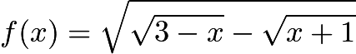 is continuous on $\left[ -1,1 \right]$, with $f(-1)=\sqrt 2$ and $f(1)=0$. Moreover, as $3-x$ is a decreasing and $x+1$ an increasing function, both $\sqrt{3-x}$ and $-\sqrt{x+1}$ are decreasing functions, and hence $f(x)$ is a decreasing function. Therefore there is exactly one solution to 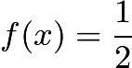.

We can now find this solution:

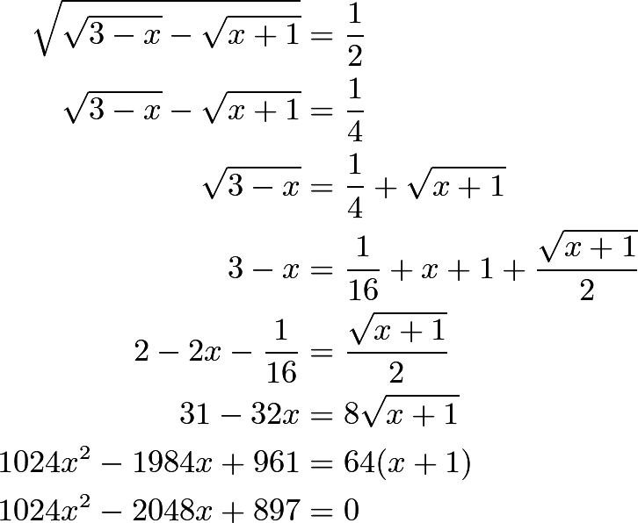

(Note the little trick in the third row: placing the square roots on opposite sides of the equation. Squaring the equation in the second row would work as well, but this way is a little more pleasant, as the one remaining square root after the squaring will essentially be one of the original two, not their product.)

Solving the quadratic equation for $x$, we get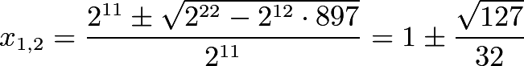

The reason why we got two roots is that while solving the original equation we squared both sides twice, and this could have created additional solutions. In this case, obviously the root that is larger than $1$ is the additional solution, and 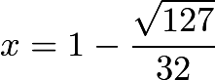 is the root we need.

Hence the solutions to the given inequality are precisely the reals in the interval 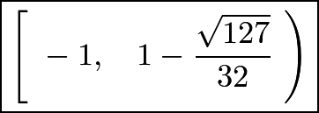.

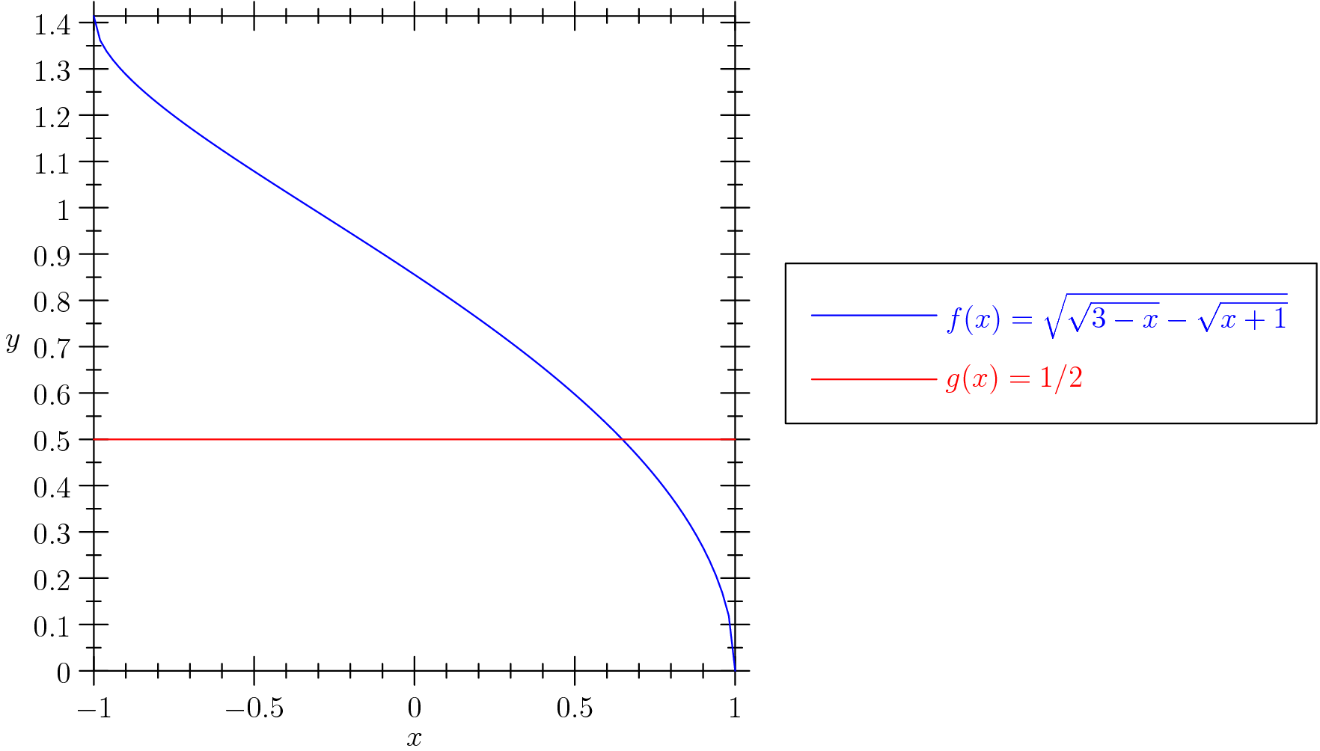

1. -
2. First, note that we can write the left hand side as a cubic function of $\cos^2 x$. So there are at most $3$ distinct values of $\cos^2 x$ that satisfy this equation. Therefore, if we find three values of $x$ that satisfy the equation and produce three different $\cos^2 x$, then we found all solutions to this cubic equation (without expanding it, which is another viable option). Indeed, we find that $\frac{\pi}2$, $\frac{\pi}4$, and $\frac{\pi}6$ all satisfy the equation, and produce three different values of $\cos^2 x$, namely $0$, $\frac12$, and $\frac34$. So we solve $\cos^2 x = \text{each of these}$. Therefore, our solutions are:



1. The key is to notice that if O is the center of the inscribed circle, then angle AOC = 270 - angle ABC (chase a few angles around and use the fact that opposite angles in a cyclic quadrilateral sum to 180). So O must be the intersection of the arc AC and the angle bisector of angle ABC. To prove the construction possible we use the fact that a quadrilateral ABCD has an inscribed circle iff AB + CD = BC + AD. For D near C on the circumcircle of ABC we have AB + CD < BC + AD, whilst for D near A we have AB + CD > BC + AD, so as D moves continuously along the circumcircle there must be a point with equality. [Proof that the condition is sufficient: it is clearly necessary (use fact that tangents from a point are of equal length). So take a circle touching AB, BC and AD and let the other tangent from C (not BC) meet AD in D'. Then CD' - CD = AD' - AD, hence D'=D.
2. Instead of an isosceles triangle, let us consider an arbitrary triangle $ABC$. Let $ABC$ have circumcenter $O$ and incenter $I$. Extend $AI$ to meet the circumcircle again at $L$. Then extend $LO$ so it meets the circumcircle again at $M$. Consider the point where the incircle meets $AB$, and let this be point $D$. We have $\angle ADI = \angle MBL = 90^{\circ}, \angle IAD = \angle LMB$; thus, $\triangle ADI \sim \triangle MBL$, or 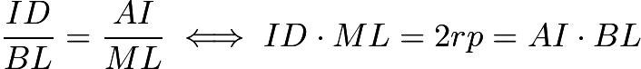. Now, drawing line $BI$, we see that . Therefore, $BIL$ is isosceles, and $IL = BL$. Substituting this back in, we have $2rp = AI\cdot IL$. Extending $OI$ to meet the circumcircle at $P,Q$, we see that $AI\cdot IL = PI\cdot QI$ by Power of a Point. Therefore, $2rp = PI \cdot QI = (PO + OI)(QO - OI) = (r + d)(r - d)$, and we have 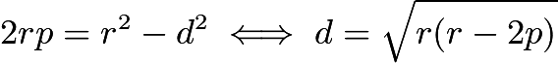, and we are done.
3. –

# **IMO 1963**

The 5th [IMO](https://www.artofproblemsolving.com/wiki/index.php?title=IMO) occurred in 1963 in Poland.

## **Day I**

### Problem 1

Find all real roots of the equation

$\sqrt{x^2-p}+2\sqrt{x^2-1}=x$,

where $p$ is a real parameter.

### Problem 2

Point $A$ and segment $BC$ are given. Determine the locus of points in space which are the vertices of right angles with one side passing through $A$, and the other side intersecting the segment $BC$.

### Problem 3

In an $n$-gon all of whose interior angles are equal, the lengths of consecutive sides satisfy the relation

$a_1\ge a_2\ge \cdots \ge a_n$.

Prove that $a_1=a_2=\cdots = a_n$.

## **Day II**

### Problem 4

Find all solutions $x_1,x_2,x_3,x_4,x_5$ of the system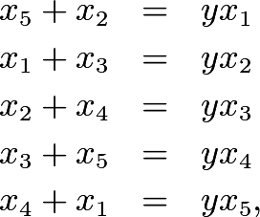where $y$ is a parameter.

### Problem 5

Prove that 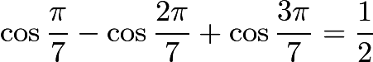.

### Problem 6

Five students, $A,B,C,D,E$, took part in a contest. One prediction was that the contestants would finish in the order $ABCDE$. This prediction was very poor. In fact no contestant finished in the position predicted, and no two contestants predicted to finish consecutively actually did so. A second prediction had the contestants finishing in the order $DAECB$. This prediction was better. Exactly two of the contestants finished in the places predicted, and two disjoint pairs of students predicted to finish consecutively actually did so. Determine the order in which the contestants finished.

IMO 1963 Solutions

1. Assuming $x \geq 0$, square the equation, obtaining 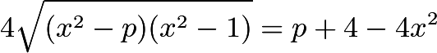. If we have $p + 4 \geq 4x^2$, we can square again, obtaining 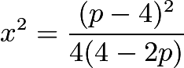, or 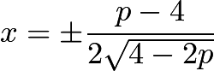. We must have $4 - 2p > 0 \iff p < 2$, so we have 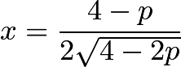. However, this is only a solution when , so we have $p\leq 0$ or 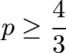. But if $p < 0$, then $\sqrt {x^2 - p} > x$, contradiction. So we have  for 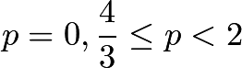.
2. –
3. Define the vector $\vec{v_i}$ to equal 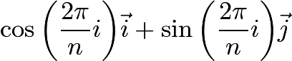. Now rotate and translate the given polygon in the Cartesian Coordinate Plane so that the side with length $a_i$ is parallel to $\vec{v_i}$. We then have that

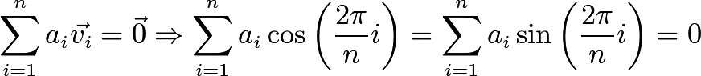

But $a_i\geq a_{n-i}$ for all 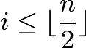, so



for all . This shows that 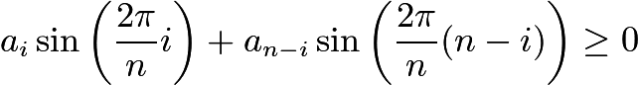, with equality when $a_i=a_{n-i}$. Therefore

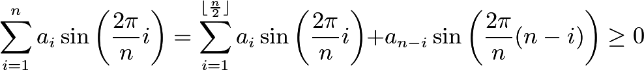

There is equality only when $a_i=a_{n-i}$ for all $i$. This implies that $a_1=a_{n-1}$ and $a_2=a_n$, so we have that $a_1=a_2=\cdots =a_n$. $\blacksquare$

1. First of all, we can add the five equations to get:

$2(x_1+x_2+x_3+x_4+x_5)=y(x_1+x_2+x_3+x_4+x_5)$

When $x_1+x_2+x_3+x_4+x_5=0$, Because $x_1,x_2,x_3,x_4,x_5$ is symmetric in the original equations,

$x_1=x_2=x_3=x_4=x_5=0$

Otherwise, dividing both sides by $(x_1+x_2+x_3+x_4+x_5$, we get $y=2$, and clearly

$x_1=x_2=x_3=x_4=x_5$

Summarizing, if $y=2$, then the answer is of the form $x_1=x_2=x_3=x_4=x_5$. Otherwise, $x_1=x_2=x_3=x_4=x_5=0$.

### Solution 1

### Let $\cos{\frac{\pi}{7}}-\cos{\frac{2\pi}{7}}+\cos{\frac{3\pi}{7}}=S$. We have



Then, by product-sum formulae, we have



Thus $S = 1/2$. $\blacksquare$

### Solution 2

Let 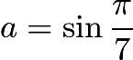 and 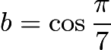. From the addition formulae, we have

\[S=b-[b^2-a^2]+[ b(b^2-a^2)-a(2ab) ]=b-b^2+b^3+a^2(1-3b)\]

From the Trigonometric Identity, $a^2=1-b^2$, so

\[S=b-b^2+b^3+(1-b^2)(1-3b)=4b^3-2b^2-2b+1\]

We must prove that $S=1/2$. It suffices to show that $8b^3-4b^2-4b+1=0$.

Now note that 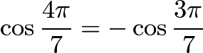. We can find these in terms of $a$ and $b$:





Therefore $8b^4-8b^2+1=-(3b-4b^3)\Rightarrow 8b^4+4b^3-8b^2-3b+1=0$. Note that this can be factored:

\[8b^4+4b^3-8b^2-3b+1=(8b^3-4b^2-4b+1)(b+1)=0\]

Clearly $b\neq -1$, so $8b^3-4b^2-4b+1=0$. This proves the result. $\blacksquare$

1. –

**IMO 1964**

The $6$th [IMO](https://www.artofproblemsolving.com/wiki/index.php?title=IMO) occurred in $1964$ in the USSR (Soviet Union).

## **Day I**

### Problem 1

(a) Find all positive integers $n$ for which $2^n-1$ is divisible by $7$.

(b) Prove that there is no positive integer $n$ for which $2^n+1$ is divisible by $7$.

### Problem 2

Suppose $a, b, c$ are the sides of a triangle. Prove that

\[a^2(b+c-a)+b^2(c+a-b)+c^2(a+b-c)\le{3abc}.\]

### Problem 3

A circle is inscribed in a triangle $ABC$ with sides $a,b,c$. Tangents to the circle parallel to the sides of the triangle are contructed. Each of these tangents cuts off a triangle from $\triangle ABC$. In each of these triangles, a circle is inscribed. Find the sum of the areas of all four inscribed circles (in terms of $a,b,c$).

## **Day II**

### Problem 4

Seventeen people correspond by mail with one another - each one with all the rest. In their letters only three different topics are discussed. Each pair of correspondents deals with only one of these topics. Prove that there are at least three people who write to each other about the same topic.

### Problem 5

Suppose five points in a plane are situated so that no two of the straight lines joining them are parallel, perpendicular, or coincident. From each point perpendiculars are drawn to all the lines joining the other four points. Determine the maximum number of intersections that these perpendiculars can have.

### Problem 6

In tetrahedron $ABCD$, vertex $D$ is connected with $D_0$, the centroid of $\triangle ABC$. Lines parallel to $DD_0$ are drawn through $A,B$ and $C$. These lines intersect the planes $BCD, CAD$ and $ABD$ in points $A_1, B_1,$ and $C_1$, respectively. Prove that the volume of $ABCD$ is one third the volume of $A_1B_1C_1D_0$. Is the result true if point $D_o$ is selected anywhere within $\triangle ABC$?



IMO 1964 Solutions

1. We see that $2^n$ is equivalent to $2, 4,$ and $1$ $\pmod{7}$ for $n$ congruent to $1$, $2$, and $0$ $\pmod{3}$, respectively.

**(a)** From the statement above, only $n$ divisible by $3$ work.

**(b)** Again from the statement above, $2^n$ can never be congruent to $-1$ $\pmod{7}$, so there are no solutions for $n$.

## **Solution 1**

We can use the substitution $a=x+y$, $b=x+z$, and $c=y+z$ to get

\[2z(x+y)^2+2y(x+z)^2+2x(y+z)^2\leq 3(x+y)(x+z)(y+z)\]

$2zx^2+2zy^2+2yx^2+2yz^2+2xy^2+2xz^2+12xyz\leq 3x^2y+3x^2z+3y^2x+3y^2z+3z^2x+3z^2y+6xyz$$2zx^2+2zy^2+2yx^2+2yz^2+2xy^2+2xz^2+12xyz\leq 3x^2y+3x^2z+3y^2x+3y^2z+3z^2x+3z^2y+6xyz$

\[x^2y+x^2z+y^2x+y^2z+z^2x+z^2y\geq 6xyz\]



This is true by AM-GM. We can work backwards to get that the original inequality is true.

## **Solution 2**

Rearrange to get\[a(a-b)(a-c) + b(b-a)(b-c) + c(c-a)(c-b) \ge 0,\]which is true by Schur's inequality.

1. Let the tangent to the in circle parallel to BC cut AB,AC at D & E respectively. Similarly let the tangent to the same parallel to AB cut AC,BC at F & G respectively and the tangent to the same parallel to AC cuts BC,AB at H,M respectively. Let the incircle touch the sides BC,CA,AB at P,Q,R respectively and let the points of contact of MH,FG,DE with the in circle be X,Y,Z respectively. Then perimeter of BHM = BH+HX+XM+MB=BH+HP+MR+BM=BP+BQ=2(s-b) and similar results follow!

Each of the triangles BHM,CGF,ADE are similar to ABC.

Thus, [BHM]+[CGF]+[ADE]=[ABC]/(a+b+c)^2 { ( b+c-a)^2 + (c+a-b)^2 + (a+b-c)^2}

Denote $[ABC]$ the area of $\triangle ABC$ and $(ABC)$ the perimeter of $\triangle ABC$.

Then 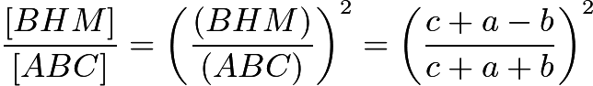.

So 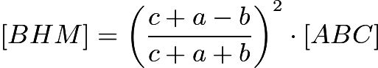.

We know, $r_{1}$ is the radius of the incircle of $\triangle BHM$: 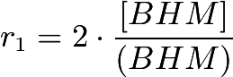.

Area of the incircle of $\triangle BHM$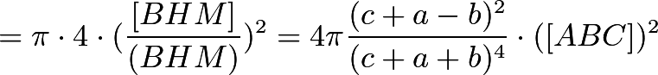Area of the incircle of $\triangle ABC$: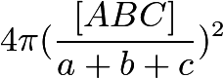.

Sum of the area of the 4 incircles: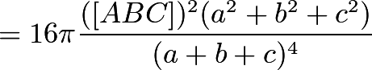

1. Lemma: Consider a complete graph with 6 vertices colored with 2 colors. There exists a monochromatic triangle.

Proof: Consider one vertex and all connections leading out from it. Call it $V_1$. It has 5 edges coming out from it. By the Pidgeonhole Principle, there are at least 3 of the same color. Call this color red. Call those vertices $V_2$, $V_3$ and $V_4$. If any of the segments $V_2V_3$, $V_2V_4$, or $V_3V_4$ are red, then we have a monochromatic triangle with vertices $V_1$ and the other two that are also red. If they are all the other color, then we have a monochromatic triangle with vertices $V_2$,$V_3$, and $V_4$.

End Lemma

Main Problem: Represent these people as vertices on a connected graph with 17 vertices and colored with 3 colors, one corresponding with each topic. So this problem is reduced to showing that on a connected graph with 17 vertices and colored with three colors, there exists some monochromatic triangle. Look at an arbitrary vertex. Call it $V_1$. Look at the 16 other vertices that it is connected to. By the Pidgeonhole Principle, there are at least 6 vertices connected to $V_1$ that are all one color. Call this color 1. If any of the connections inbetween these six vertices are in color 1, then we are done. If none of them are color 1, we know that that there are only 2 colors in those 6 vertices. By Lemma 1, we know that there is a monochromatic triangle in those 6 vertices. So we are done.

**There is no solution yet to Problem 5 and 6.**

**IMO 1965**

The 7th [IMO](https://www.artofproblemsolving.com/wiki/index.php?title=IMO) occurred in 1965 in East Germany.

## **Problem 1**

Determine all values $x$ in the interval $0\leq x\leq 2\pi$ which satisfy the inequality

## **Problem 2**

Consider the system of equations

\[a_{11}x_1 + a_{12}x_2 + a_{13}x_3 = 0\]

\[a_{21}x_1 + a_{22}x_2 + a_{23}x_3 = 0\]

\[a_{31}x_1 + a_{32}x_2 + a_{33}x_3 = 0\]

with unknowns $x_1$, $x_2$, $x_3$. The coefficients satisfy the conditions:

(a) $a_{11}$, $a_{22}$, $a_{33}$ are positive numbers;

(b) the remaining coefficients are negative numbers;

(c) in each equation, the sum of the coefficients is positive.

Prove that the given system has only the solution $x_1 = x_2 = x_3 = 0$.

## **Problem 3**

Given the tetrahedron $ABCD$ whose edges $AB$ and $CD$ have lengths $a$ and $b$ respectively. The distance between the skew lines $AB$ and$CD$ is $d$, and the angle between them is $\omega$. Tetrahedron $ABCD$ is divided into two solids by plane $\varepsilon$, parallel to lines $AB$ and $CD$. The ratio of the distances of $\varepsilon$ from $AB$ and $CD$ is equal to $k$. Compute the ratio of the volumes of the two solids obtained.

## **Problem 4**

Find all sets of four real numbers $x_1$, $x_2$, $x_3$, $x_4$ such that the sum of any one and the product of the other three is equal to $2$.

## **Problem 5**

Consider $\triangle OAB$ with acute angle $AOB$. Through a point $M \neq O$ perpendiculars are drawn to $OA$ and $OB$, the feet of which are $P$ and $Q$ respectively. The point of intersection of the altitudes of $\triangle OPQ$ is $H$. What is the locus of $H$ if $M$ is permitted to range over (a) the side $AB$, (b) the interior of $\triangle OAB$?

## **Problem 6**

In a plane a set of $n$ points ($n\geq 3$) is given. Each pair of points is connected by a segment. Let $d$ be the length of the longest of these segments. We define a diameter of the set to be any connecting segment of length $d$. Prove that the number of diameters of the given set is at most $n$.



IMO 1965 Solutions

1. We shall deal with the left side of the inequality first (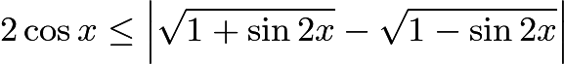) and the right side after that.

It is clear that the left inequality is true when $\cos x$ is non-positive, and that is when $x$ is in the interval $[\pi/2, 3\pi/2]$. We shall now consider when $\cos x$ is positive. We can square the given inequality, and the resulting inequality will be true whenever the original left inequality is true. $4\cos^2{x}\leq 1+\sin 2x+1-\sin 2x-2\sqrt{1-\sin^2 2x}=2-2\sqrt{\cos^2{2x}}$. This inequality is equivalent to $2\cos^2 x\leq 1-\left| \cos 2x\right|$. I shall now divide this problem into cases.

**Case 1:** $\cos 2x$ is non-negative. This means that $x$ is in one of the intervals $[0,\pi/4]$ or $[7\pi/4, 2\pi]$. We must find all $x$ in these two intervals such that $2\cos^2 x\leq 1-\cos 2x$. This inequality is equivalent to $2\cos^2 x\leq 2\sin^2 x$, which is only true when $x=\pi/4$ or $7\pi/4$.

**Case 2:** $\cos 2x$ is negative. This means that $x$ is in one of the interavals $(\pi/4, \pi/2)$ or $(3\pi/2, 7\pi/4)$. We must find all $x$ in these two intervals such that $2\cos^2 x\leq 1+\cos 2x$, which is equivalent to $2\cos^2 x\leq 2\cos^2 x$, which is true for all $x$ in these intervals.

Therefore the left inequality is true when $x$ is in the union of the intervals $[\pi/4, \pi/2)$, $(3\pi/2, 7\pi/4]$, and $[\pi/2, 3\pi/2]$, which is the interval $[\pi/4, 7\pi/4]$. We shall now deal with the right inequality.

As above, we can square it and have it be true whenever the original right inequality is true, so we do that. $2-2\sqrt{\cos^2{2x}}\leq 2$, which is always true. Therefore the original right inequality is always satisfied, and all $x$ such that the original inequality is satisfied are in the interval $[\pi/4, 7\pi/4]$.

1. Clearly if the $x_i$ are all equal, then they are equal to 0. Now let's assume WLOG that $x_1=0$. If $x_2$ or $x_3$ is 0, then the other is clearly zero, so let's consider the case where neither are 0. $a_{12}$ and $a_{21}$ are negative, so exactly one of $x_2$ or $x_3$ is positive. Unfortunately this means that one of $a_{22}x_2 + a_{23}x_3$ or $a_{32}x_2 + a_{33}x_3 = 0$ is positive and the other is negative, so the equation couldn't possibly be satisfied if $x_2$ or $x_3$ isn't 0. We have covered the case where one of the $x_i$ is 0, now let's assume that none of them are 0.

If two are positive and one is negative, then when the negative $x_i$ is paired with one of the positive $a_i$, the corresponding equation is negative. This is bad. If two are negative and one is positive, then when the positive $x_i$ is paired with one of the positive $a_i$, the corresponding equation is positive. This is also bad. Therefore the $x_i$ all have the same sign.

**Case 1:** The $x_i$ are all positive. WLOG $x_1\leq x_2\leq x_3$. Now consider the third equation, $a_{31}x_1 + a_{32}x_2 + a_{33}x_3 = 0$. Therefore $x_2(a_{31} +a_{32}+a_{33})+ a_{31}(x_1-x_2)+a_{33}(x_3-x_2)= 0$, but all of the terms on the LHS are non-negative and the first one is positive, so this is impossible.

**Case 2:** The $x_i$ are all negative. WLOG $x_1\geq x_2\geq x_3$. Consider the third equation, $a_{31}x_1 + a_{32}x_2 + a_{33}x_3 = 0$. Therefore $x_3(a_{31}+a_{32}+a_{33})+a_{31}(x_1-x_3)+a_{32}(x_2-x_3)=0$, but all of the terms on the LHS are non-positive and the first one is negative, so this is impossible.

Therefore at least one of the $x_i$ is 0, which implies all of them are 0.

1. –
2. Let $P = x_1x_2x_3x_4$ be the product of the four real numbers.

Then, for $i = 1,2,3,4$ we have: 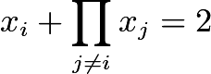.

Multiplying by $x_i$ yields:

$x^2_i + P = 2x_i \Longleftrightarrow x^2_i-2x_i+1 = (x_i-1)^2 = 1-P \Longleftrightarrow x_i = 1 \pm t$ where $t = \pm \sqrt{1-P} \in \mathbb{R}$.

If $t=0$, then we have $(x_1,x_2,x_3,x_4)=(1,1,1,1)$ which is a solution.

So assume that $t \neq 0$. WLOG, let at least two of $x_i$ equal $1+t$, and $x_1 \ge x_2 \ge x_3 \ge x_4$ OR $x_1 \le x_2 \le x_3 \le x_4$.

**Case I:** $x_1 = x_2 = x_3 = x_4 = 1+t$

Then we have:

$(1+t)+(1+t)^3 = 2 \Longleftrightarrow t^3+3t^2+4t = 0 \Longleftrightarrow t(t^2+3t+4) = 0$

Which has no non-zero solutions for $t$.

**Case II:** $x_1 = x_2 = x_3 = 1+t$ AND $x_4 = 1-t$

Then we have:

$(1-t)+(1+t)^3 = 2 \Longleftrightarrow t^3+3t^2+2t = 0$ $\Longleftrightarrow t(t+1)(t+2) = 0 \Longleftrightarrow t \in \{0,-1,-2\}$

AND

$(1+t)+(1-t)(1+t)^2 = 2 (1+t)+(1-t)(1+t)^2 = 2 -t^3-t^2+2t = 0$ $\Longleftrightarrow -t(t-1)(t+2) = 0 \Longleftrightarrow t \in \{0,1,-2\}$

So, we have $t = -2$ as the only non-zero solution, and thus, $(x_1,x_2,x_3,x_4) = (-1,-1,-1,3)$ and all permutations are solutions.

**Case III:** $x_1 = x_2 = 1+t$ AND $x_3 = x_4 = 1-t$

Then we have:

$(1-t)+(1-t)(1+t)^2 = 2 \Longleftrightarrow -t^3-t^2 = 0$ $\Longleftrightarrow -t^2(t+1) = 0 \Longleftrightarrow t \in \{0,-1\}$

AND

$(1+t)+(1+t)(1-t)^2 = 2 \Longleftrightarrow t^3-t^2 = 0$ $\Longleftrightarrow t^2(t-1) = 0 \Longleftrightarrow t \in \{0,1\}$

Thus, there are no non-zero solutions for $t$ in this case.

Therefore, the solutions are: $(1,1,1,1)$; $(3,-1,-1,-1)$; $(-1,3,-1,-1)$; $(-1,-1,3,-1)$; $(-1,-1,-1,3)$.

1. Let $O(0,0),A(a,0),B(b,c)$. Equation of the line 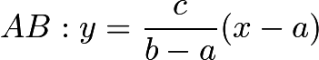. Point 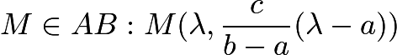. Easy, point $P(\lambda,0)$. Point $Q = OB \cap MQ$, $MQ \bot OB$. Equation of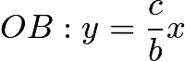, equation of 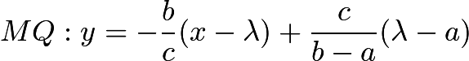. Solving: 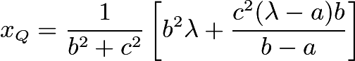. Equation of the first altitude: 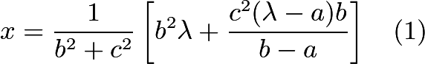. Equation of the second altitude: 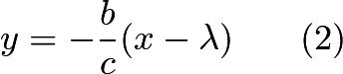. Eliminating $\lambda$ from (1) and (2):\[ac \cdot x + (b^{2}+c^{2}-ab)y=abc\]a line segment $MN , M \in OA , N \in OB$. Second question: the locus consists in the $\triangle OMN$.
2. –

**IMO 1966**

The 8th [IMO](https://www.artofproblemsolving.com/wiki/index.php?title=IMO) occurred in 1966 in Bulgaria.

## **Problem 1**

In a mathematical contest, three problems, $A,B,C$ were posed. Among the participants there were 25 students who solved at least one problem each. Of all the contestants who did not solve problem $A$, the number who solved $B$ was twice the number who solved $C$. The number of students who solved only problem $A$ was one more than the number of students who solved $A$ and at least one other problem. Of all students who solved just one problem, half did not solve problem $A$. How many students solved only problem $B$?

## **Problem 2**

Let $a,b,c$ be the lengths of the sides of a triangle, and $\alpha, \beta, \gamma$ respectively, the angles opposite these sides. Prove that if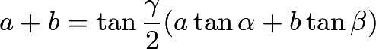the triangle is isosceles.

## **Problem 3**

Prove that the sum of the distances of the vertices of a regular tetrahedron from the center of its circumscribed sphere is less than the sum of the distances of these vertices from any other point in space.

## **Problem 4**

Prove that for every natural number $n$, and for every real number 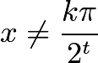 ($t=0,1, \dots, n$; $k$ any integer)

## **Problem 5**

Solve the system of equations\[|a_1-a_2|x_2+|a_1-a_3|x_3+|a_1-a_4|x_4=1\]\[|a_2-a_1|x_1+|a_2-a_3|x_3+|a_2-a_4|x_4=1\]\[|a_3-a_1|x_1+|a_3-a_2|x_2+|a_3-a_4|x_4=1\]\[|a_4-a_1|x_1+|a_4-a_2|x_2+|a_4-a_3|x_3=1\]where $a_1, a_2, a_3, a_4$ are four different real numbers.

## **Problem 6**

Let $ABC$ be a triangle, and let $P$, $Q$, $R$ be three points in the interiors of the sides $BC$, $CA$, $AB$ of this triangle. Prove that the area of at least one of the three triangles $AQR$, $BRP$, $CPQ$ is less than or equal to one quarter of the area of triangle $ABC$.

*Alternative formulation:* Let $ABC$ be a triangle, and let $P$, $Q$, $R$ be three points on the segments $BC$, $CA$, $AB$, respectively. Prove that

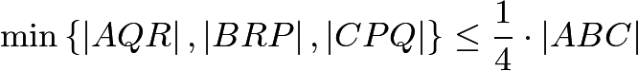,

where the abbreviation $\left|P_1P_2P_3\right|$ denotes the (non-directed) area of an arbitrary triangle $P_1P_2P_3$.



IMO 1966 Solutions

1. Let us draw a Venn Diagram.

Let $a$ be the number of students solving both B and C. Then for some positive integer $x$, $2x - a$ students solved B only, and $x - a$ students solved C only. Let $2y - 1$ be the number of students solving A; then $y$ is the number of students solving A only. We have by given\[2y - 1 + 3x - a = 25\]and\[y = 3x - 2a.\]Substituting for y into the first equation gives\[9x - 5a = 26.\]Thus, because $x$ and $a$ are positive integers with $x-a \ge 0$, we have $x = 4$ and $a = 2$. (Note that $x = 9$ and $a = 11$ does not work.) Hence, the number of students solving B only is $2x - a = 8 - 2 = \boxed{6}.$

1. –
2. –
3. Assume that  is true, then we use $n=1$ and get 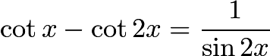.

First, we prove 

LHS=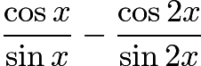

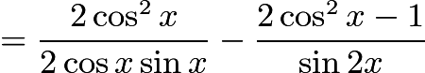

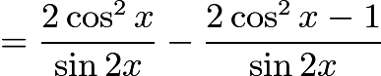

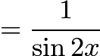

Using the above formula, we can rewrite the original series as

$\cot x - \cot 2x + \cot 2x - \cot 4x + \cot 4x \cdot \cdot \cdot + \cot 2^{n-1} x - \cot 2^n x$

Which gives us the desired answer of $\cot x - \cot 2^n x$

1. Take a1 > a2 > a3 > a4. Subtracting the equation for i=2 from that for i=1 and dividing by (a1 - a2) we get:

- x1 + x2 + x3 + x4 = 0.

Subtracting the equation for i=4 from that for i=3 and dividing by (a3 - a4) we get:

- x1 - x2 - x3 + x4 = 0.

Hence x1 = x4. Subtracting the equation for i=3 from that for i=2 and dividing by (a2 - a3) we get:

- x1 - x2 + x3 + x4 = 0.

Hence x2 = x3 = 0, and x1 = x4 = 1/(a1 - a4).

## **Solution 1**

Let the lengths of sides $BC$, $CA$, and $AB$ be $a$, $b$, and $c$, respectively. Let $BK=d$, $CL=e$, and $AM=f$.

Now assume for the sake of contradiction that the areas of $\Delta AML$, $\Delta BKM$, and $\Delta CLK$ are all at greater than one fourth of that of $\Delta ABC$. Therefore



In other words, 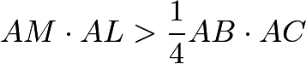, or 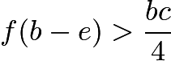. Similarly, 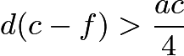 and 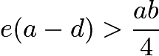. Multiplying these three inequalities together yields

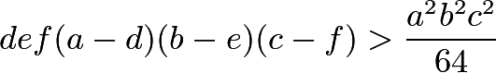

We also have that 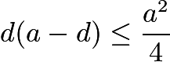, 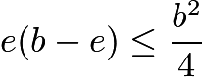, and 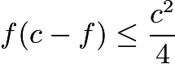 from the [Arithmetic Mean-Geometric Mean Inequality](https://www.artofproblemsolving.com/wiki/index.php?title=Arithmetic_Mean-Geometric_Mean_Inequality). Multiplying these three inequalities together yields

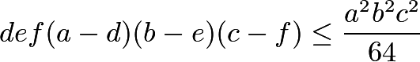

This is a contradiction, which shows that our assumption must have been false in the first place. This proves the desired result.

## **Solution 2**

Let $AR : AB = x, BP : BC = y, CQ : CA = z$. Then it is clear that the ratio of areas of $AQR, BPR, CPQ$ to that of $ABC$ equals $x(1-y), y(1-z), z(1-x)$, respectively. Suppose all three quantities exceed $\frac{1}{4}$. Then their product also exceeds $\frac{1}{64}$. However, it is clear by AM-GM that 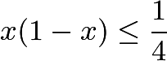, and so the product of all three quantities cannot exceed $\frac{1}{64}$ (by the associative property of multiplication), a contradiction. Hence, at least one area is less than or equal to 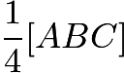.

**IMO 1967**

The 9th [IMO](https://www.artofproblemsolving.com/wiki/index.php?title=IMO) occurred in 1967 in Yugoslavia.

## **Problem 1**

Let $ABCD$ be a parallelogram with side lengths $AB = a$, $AD = 1$, and with $\angle BAD = \alpha$. If $\triangle ABD$ is acute, prove that the four circles of radius $1$ with centers $A$, $B$, $C$, $D$ cover the parallelogram if and only if\[a\leq \cos \alpha + \sqrt{3} \sin \alpha .\]

## **Problem 2**

Prove that if one and only one edge of a tetrahedron is greater than $1$, then its volume is $\leq 1/8$.

## **Problem 3**

Let $k$, $m$, $n$ be natural numbers such that $m + k + 1$ is a prime greater than $n + 1$. Let $c_s = s(s + 1)$. Prove that the product\[(c_{m+1} - c_k)(c_{m+2}- c_k)\cdots (c_{m+n}- c_k)\]is divisible by the product $c_1 c_2\cdots c_n$.

## **Problem 4**

Let $A_0 B_0 C_0$ and $A_1 B_1 C_1$ be any two acute-angled triangles. Consider all triangles $ABC$ that are similar to $\triangle A_1 B_1 C_1$ (so that vertices $A_1$, $B_1$, $C_1$ correspond to vertices $A$, $B$, $C$, respectively) and circumscribed about triangle $A_0 B_0 C_0$ (where $A_0$ lies on $BC$, $B_0$ on $CA$, and $C_0$on $AB$). Of all such possible triangles, determine the one with maximum area, and construct it.

## **Problem 5**

Consider the sequence $\{ c_n \}$, where\[c_1 = a_1 + a_2 + \cdots + a_8\]\[c_2 = a_1^2 + a_2^2 + \cdots + a_8^2\]\[\cdots\]\[c_n = a_1^n + a_2^n + \cdots + a_8^n\]\[\cdots\]in which $a_1$, $a_2$, $\cdots$, $a_8$ are real numbers not all equal to zero. Suppose that an infinite number of terms of the sequence $\{ c_n \}$ are equal to zero. Find all natural numbers $n$ for which $c_n = 0$.

## **Problem 6**

In a sports contest, there were $m$ medals awarded on $n$ successive days ($n>1$). On the first day, one medal and $1/7$ of the remaining $m - 1$ medals were awarded. On the second day, two medals and $1/7$ of the now remaining medals were awarded; and so on. On the $n$-th and last day, the remaining $n$ medals were awarded. How many days did the contest last, and how many medals were awarded altogether?



IMO 1967 Solutions

1. To start our proof we draw a parallelogram with the requested sides. We notice that by drawing the circles with centers A, B, C, D that the length of $a$ must not exceed 2 (the radius for each circle) or the circles will not meet and thus not cover the parallelogram.

To prove our conjecture we draw a parallelogram with $a=2$ and draw a segment $DB$ so that $\angle ADB=90^{\circ}$

This is the parallelogram which we claim has the maximum length on $a$ and the highest value on any one angle.

We now have two triangles inside a parallelogram with lengths $1, 2$ and $x$, $x$ being segment $DB$. Using the Pythagorean theorem we conclude:

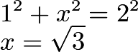

Using trigonometric functions we can compute:

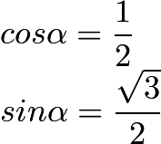

Notice that by applying the $arcsine$ and $arccos$ functions, we can conclude that our angle $\alpha=60^{\circ}$

To conclude our proof we make sure that our values match the required values for maximum length of $a$

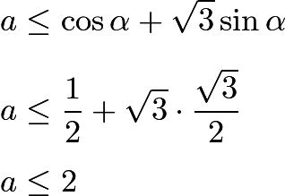

Notice that as $\angle\alpha$ decreases, the value of (1) increases beyond 2. We can prove this using the law of sines. Similarly as $\angle\alpha$ increases, the value of (1) decreases below 2, confirming that (1) is only implied when $\Delta ABD$ is acute.

1. Let the tetrahedron be ABCD and assume that all edges except AB have length at most 1. The volume is the 1/3 x area BCD x height of A above BCD. The height is at most the height of A above CD, so we maximise the volume by taking the planes ACD and BCD to be perpendicular. If AC or AD is less than 1, then we can increase the altitude from A to CD whilst keeping BCD fixed by taking AC = AD = 1. A similar argument shows that we must have BC = BD = 1.

But the volume is also the 1/3 x area ABC x height of D above ABC, so we must adjust CD to maximise this height. We want the angle between planes ABC and ABD to be as close as possible to 90o. The angle increases with increasing CD until it becomes 90o. CMD is then a right-angled triangle. Now the angle ACB must be less than the angle between the planes ACD and BCD and hence < 90o, so angle ACM < 45o, so CM > 1/√2. Similarly DM. Hence when CMD = 90o we have CD > 1. Thus we maximise the height of D above ABC by taking CD = 1.

So BCD is equilateral with area (√3)/4. ACD is also equilateral with altitude (√3)/2. Since the planes ACD and BCD are perpendicular, that is also the height of A above BCD. So the volume is 1/3 x(√3)/4 x (√3)/2 = 1/8.

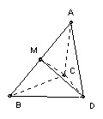

1. The key is that ca - cb = (a - b)(a + b + 1). Hence the product (cm+1 - ck)(cm+2 - ck) ... (cm+n - ck) is the product of the n consecutive numbers (m - k + 1), ... , (m - k + n), times the product of the n consecutive numbers (m + k + 2), ... , (m + k + n + 1). The first product is just the binomial coefficient (m-k+n)Cn times n!, so it is divisible by n!. The second product is 1/(m + k + 1) x (m + k + 1)(m + k + 2) ... (m + k + n + 1) = 1/(m + k + 1) x (m+k+n+1)C(n+1) x (n+1)!. But m + k + 1 is a prime greater than n + 1, so it has no factors in common with (n+1)!, hence the second product is divisible by (n+1)!. Finally note that c1c2 ... cn= n! (n+1)!.
2. Take any triangle similar to A\_1B\_1C\_1 and circumscribing A\_0B\_0C\_0. For example, take an arbitrary line through A\_0 and then lines through B\_0 and C\_0 at the appropriate angles to the first line. Label the triangle's vertices X, Y, Z so that A\_0 lies on YZ, B\_0 on ZX, and C\_0 on XY. Now any circumscribed ABC (labeled with the same convention) must have C on the circle through A\_0, B\_0 and Z, because it has angle C = angle Z = angle C\_1. Similarly it must have B on the circle through C\_0, A\_0 and Y, and it must have A on the circle through B\_0, C\_0 and X. Consider the side AB. It passes through C\_0. Its length is twice the projection of the line joining the centers of the two circles onto AB (because each center projects onto the midpoint of the part of AB that is a chord of its circle). But this projection is maximum when it is parallel to the line joining the two centers. The area is maximized when AB is maximized (because all the triangles are similar), so we take AB parallel to the line joining the centers. [Note, in passing, that this proves that the other sides must also be parallel to the lines joining the respective centers and hence that the three centers form a triangle similar to A\_1B\_1C\_1.]

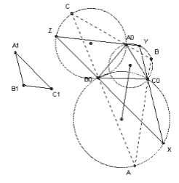

1. Take |a1| >= |a2| >= ... >= |a8|. Suppose that |a1|, ... , |ar| are all equal and greater than |ar+1|. Then for sufficiently large n, we can ensure that |as|n < 1/8 |a1|n for s > r, and hence the sum of |as|n for all s > r is less than |a1|n. Hence r must be even with half of a1, ... , ar positive and half negative.

If that does not exhaust the ai, then in a similar way there must be an even number of ai with the next largest value of |ai|, with half positive and half negative, and so on. Thus we find that cn = 0 for all odd n.

1. Let the number of medals remaining at the start of day r be mr. Then m1 = m, and 6(mk - k)/7 = mk+1 for k < n with mn = n.

After a little rearrangement, we find that m = 1 + 2(7/6) + 3(7/6)2 + ... + n(7/6)n-1. Summing, we get m = 36(1 - (n + 1)(7/6)n + n (7/6)n+1) = 36 + (n - 6)7n/6n-1. 6 and 7 are coprime, so 6n-1 must divide n - 6. But 6n-1 > n - 6, so n = 6 and m = 36.

**IMO 1968**

The 10th [IMO](https://www.artofproblemsolving.com/wiki/index.php?title=IMO) occurred in 1968 in USSR.

## **Problem 1**

Prove that there is one and only one triangle whose side lengths are consecutive integers, and one of whose angles is twice as large as another.

## **Problem 2**

Find all natural numbers $x$ such that the product of their digits (in decimal notation) is equal to $x^2 - 10x - 22$.

## **Problem 3**

Consider the system of equations\[ax_1^2 + bx_1 + c = x_2\]\[ax_2^2 + bx_2 + c = x_3\]\[\cdots\]\[ax_{n-1}^2 + bx_{n-1} + c = x_n\]\[ax_n^2 + bx_n + c = x_1\]with unknowns $x_1, x_2, \cdots, x_n$ where $a, b, c$ are real and $a \neq 0$. Let $\Delta = (b - 1)^2 - 4ac$. Prove that for this system

(a) if $\Delta < 0$, there is no solution,

(b) if $\Delta = 0$, there is exactly one solution,

(c) if $\Delta > 0$, there is more than one solution.

## **Problem 4**

Prove that in every tetrahedron there is a vertex such that the three edges meeting there have lengths which are the sides of a triangle.

## **Problem 5**

Let $f$ be a real-valued function defined for all real numbers $x$ such that, for some positive constant $a$, the equation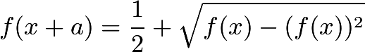holds for all $x$.

(a) Prove that the function $f$ is periodic (i.e., there exists a positive number $b$ such that $f(x + b) = f(x)$ for all $x$).

(b) For $a = 1$, give an example of a non-constant function with the required properties.

## **Problem 6**

For every natural number $n$, evaluate the sum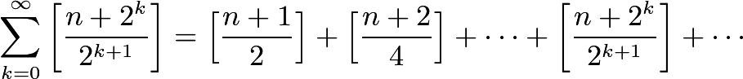(The symbol $[x]$ denotes the greatest integer not exceeding $x$.)



IMO 1968 Solutions

## **Solution 1**

In triangle $ABC$, let $BC=a$, $AC=b$, $AB=c$, $\angle ABC=\alpha$, and $\angle BAC=2\alpha$. Using the [Law of Sines](https://www.artofproblemsolving.com/wiki/index.php?title=Law_of_Sines) gives that

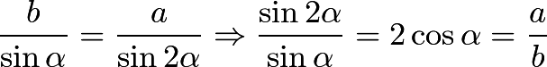

Therefore 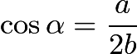. Using the [Law of Cosines](https://www.artofproblemsolving.com/wiki/index.php?title=Law_of_Cosines) gives that

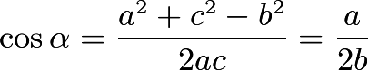

This can be simplified to $a^2c=b(a^2+c^2-b^2)$. Since $a$, $b$, and $c$ are positive integers, $b|a^2c$. Note that if $b$ is between $a$ and $c$, then $b$ is relatively prime to $a$ and $c$, and $b$ cannot possibly divide $a^2c$. Therefore $b$ is either the least of the three consecutive integers or the greatest.

Assume that $b$ is the least of the three consecutive integers. Then either $b|b+2$ or $b|(b+2)^2$, depending on if $a=b+2$ or $c=b+2$. If $b|b+2$, then $b$ is 1 or 2. $b$ couldn't be 1, for if it was then the triangle would be degenerate. If $b$ is 2, then $b(a^2+c^2-b^2)=42=a^2c$, but $a$ and $c$ must be 3 and 4 in some order, which means that this triangle doesn't exist. therefore $b$ cannot divide $b+2$, and so $b$ must divide $(b+2)^2$. If $b|(b+2)^2$ then $b|(b+2)^2-b^2-4b=4$, so $b$ is 1, 2, or 4. Clearly $b$ cannot be 1 or 2, so $b$ must be 4. Therefore $b(a^2+c^2-b^2)=180=a^2c$. This shows that $a=6$ and $c=5$, and the triangle has sides that measure 4, 5, and 6.

Now assume that $b$ is the greatest of the three consecutive integers. Then either $b|b-2$ or $b|(b-2)^2$, depending on if $a=b-2$ or $c=b-2$. $b|b-2$ is absurd, so $b|(b-2)^2$, and $b|(b-2)^2-b^2+4b=4$. Therefore $b$ is 1, 2, or 4. However, all of these cases are either degenerate or have been previously ruled out, so $b$ cannot be the greatest of the three consecutive integers. This shows that there is exactly one triangle with this property - and it has side lengths of 4, 5, and 6. $\blacksquare$

## **Solution 2**

if in a triangle one angle is twice the other . Say in tr. ABC angle A=2angle B A=2B which implies C=180-3B SinC=Sin3B Sin^2A = Sin^2 2B= 2sinBcosBSin2B = sinB(SinB + Sin3B) = SinB(SinB + SinC) Hence, **a^2 = b(b+c)** using the above relation we check for triangle with consecutive sides. Putting b as the smallest, (b+2)^2 = b^2 +b(b+1) (b-4)(b+1)=0 b=4,c=5,a=6 putting similar cases we can show that all other solutions are non-integral

## **Solution 3**

NO TRIGONOMETRY!!!

Let $a, b, c$ be the side lengths of a triangle in which $<C = 2<B.$

Extend $AC$ to $D$ such that $CD = BC = a.$ Then $<CDB = <ACB/2 = <ABC$, so $ABC$ and $ADB$ are similar by AA Similarity. Hence, $c^2 = b(a+b)$. Then proceed as in Solution 2, as only algebraic manipulations are left.

1. Let the decimal expansion of $x$ be $\overline{d_1d_2d_3\dots d_n}$, where $d_i$ are base-10 digits. We then have that $x\geq d_1\cdot 10^{n-1}$. However, the product of the digits of $x$ is $d_1d_2d_3\dots d_n\leq d_1\cdot 10\cdot 10\dots 10=d_1\cdot 10^{n-1}$, with equality only when $x$ is a one-digit integer. Therefore the product of the digits of $x$ is always at most $x$, with equality only when $x$ is a base-10 digit. This implies that $x^2-10x-22\leq x$, so $x^2-11x-22\leq 0$. Every natural number from 1 to 12 satisfies this inequality, so we only need to check these possibilities. It is easy to rule out 1 through 11, since $x^2-10x-22<0$ for those values. However, $12^2-10\cdot 12-22=2$, which is the product of the digits of 12. Therefore $\boxed{12}$ is the only natural number with the desired properties. $\blacksquare$
2. Adding the $n$ equations together yields

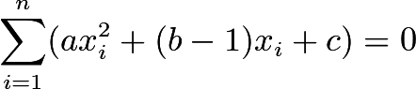

Let $s_i=ax_i^2+(b-1)x_i+c$.

(a) If $\Delta<0$, then there is no solution to the quadratic equation $ax^2+(b-1)x+c$, as the determinant is negative. This implies that either $s_i>0$ for all $i$, or $s_i<0$ for all $i$. In either case the above summation cannot be 0, which implies that there are no solutions to the given system of equations. $\blacksquare$

(b) If $\Delta=0$, then there is exactly one solution to the quadratic equation $ax^2+(b-1)x+c$ (let it be $r$), and either $s_i\geq 0$ for all $i$, or $s_i\leq 0$ for all $i$. The only way that the above summation is 0 is if $s_i=0$ for all $i$. As there is exactly one $x_i$ that makes $s_i=0$ (namely $x_i=r$), then the only possible solution to the system of equations is $(x_1,x_2,\dots , x_n)=(r, r, \dots , r)$. It's not hard to show that this works, so when $\Delta=0$ the system of equations has exactly one solution. $\blacksquare$

(c) If $\Delta>1$, then there are exactly two solutions to the quadratic equation $ax^2+(b-1)x+c$. Let the roots be $r_1$ and $r_2$. If $x_i=r_1$ for all $i$, then $ax_i^2+bx_i+c=ar_1^2+br_1+c=r_1=x_{i+1}$. This shows that $(x_1,x_2,\dots ,x_n)=(r_1,r_1,\dots, r_1)$ is a solution. We can show that $(x_1,x_2,\dots ,x_n)=(r_2,r_2,\dots, r_2)$ is another solution using the same reasoning, which shows that the equation has more than one solution. $\blacksquare$

1. Let the edges of one of the faces of the tetrahedron have lengths $a$, $b$, and $c$. Let $d$, $e$, and $f$ be the lengths of the sides that are not adjacent to the sides with lengths $a$, $b$, and $c$, respectively.

Without loss of generality, assume that $\max(a,b,c,d,e,f)=a$. I shall now prove that either $b+f>a$ or $c+e>a$, by proving that if $b+f\leq a$, then $c+e>a$.

Assume that $b+f\leq a$. The triangle inequality gives us that $e+f>a$, so $e$ must be greater than $b$. We also have from the triangle inequality that $b+c>a$. Therefore $e+c>b+c>a$. Therefore either $b+f>a$ or $c+e>a$.

If $b+f>a$, then the vertex where the sides of length $a$, $b$, and $f$ meet satisfies the given condition. If $c+e>a$, then the vertex where the sides of length $a$, $c$, and $e$ meet satisfies the given condition. This proves the statement. $\blacksquare$

1. (a) Since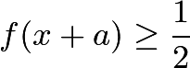is true for any $x$, and

We have:Therefore $f$ is periodic, with $2a>0$ as a period.

(b) $f(x) = 1$ when $2n\le x < 2n+1$ for some integer $n$, and  when $2n+1\le x < 2n+2$ for some integer $n$.

1. I shall prove that the summation is equal to $n$.

Let the binary representation of $n$ be $\overline{d_xd_{x-1}\dots d_1d_0}_2$, where $d_i\in\{0,1\}$ for all $i$, and $x=\lfloor \log_2 n\rfloor$. Note that if $d_i=0$, then 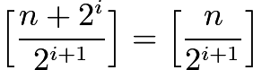; and if $d_i=1$, then 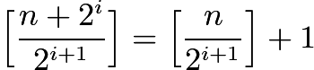. Also note that 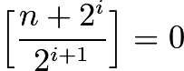 for all $i\geq x+1$. Therefore the given sum is equal to

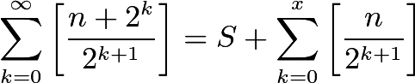

where $S$ is the number of 1's in the binary representation of $n$. [Legendre's Formula](https://www.artofproblemsolving.com/wiki/index.php?title=Legendre%27s_Formula) states that 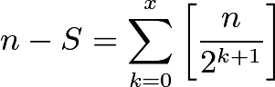, which proves the assertion. $\blacksquare$

Source :

<http://www.artofproblemsolving.com/wiki/index.php?title=IMO_Problems_and_Solutions>

